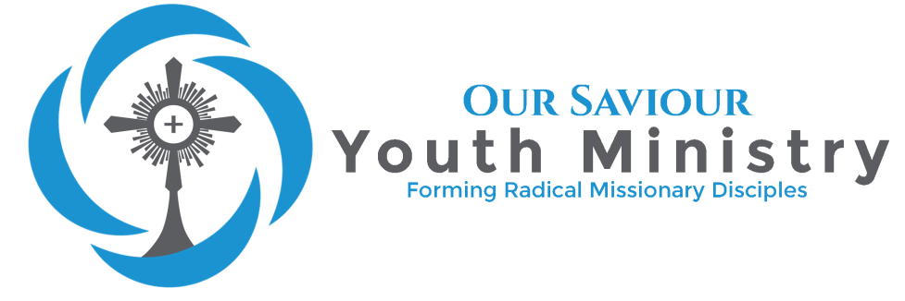
Church of Our Saviour
Confirmation Registration and Information 2018-2019
Confirmation Mass will be April 6th at 4pm, Bishop Noonan conferring the Sacrament

Please read the entire packet and be familiar with the information.

Welcome to Confirmation Preparation!

What is Confirmation Preparation?
The Code of Cannon Law says that in order for a person to receive the Sacrament of Confirmation, the person must be “suitably instructed, properly disposed, and able to renew the baptismal promise” (CIC 889). This year will give candidates a deeper knowledge and grasp of the teachings of the Catholic Church. We also focus on forming a faith-rooted community that gives our candidates the resources they need to live as Catholics after Confirmation.

Why receive Confirmation?
Living out and understanding our faith is not easy in this world. Knowing the struggle we would face, Jesus gave us the Advocate, the Holy Spirit, to strengthen us. The Catechism of the Catholic Church says “This fullness of the Spirit was not to remain uniquely the Messiah's, but was to be communicated to the whole messianic people” (CCC 1287). At Pentecost, the Holy Spirit was given to the first disciples to help them know and preach the Truth. Today, we receive that same Spirit to empower us to be a force for good in our world. As the Catechism also says “By the sacrament of Confirmation, [the baptized] are more perfectly bound to the Church and are enriched with a special strength of the Holy Spirit. Hence they are, as true witnesses of Christ, more strictly obliged to spread and defend the faith by word and deed" (CCC 1285).

What is the Catechism of the Catholic Church and the Code of Cannon Law?
As a Church, since the time of the Apostles, what we believe as doctrine has not changed. The Catechism summarizes our faith and what we believe. It is a resource to help us know our faith and the Lord. The Code of Cannon Law lists the rules we as Catholics must follow. Both are important works for us as Catholics to look to when we have questions about how to live our faith. During the Preparation, candidates will learn about both.

Why are candidates required to go to Sunday meetings?
Our faith is not meant to be lived on an island. We are meant to grow together. During these meetings, we help build that community, seek truth, and learn the reasons for our faith. Confirmation Preparation is not meant only to give candidates the important head knowledge. This time is also to help them understand why the Church says what she does and how to practically live the faith.

What are you supposed to do as a family as your child prepares?
As you probably know, you are the greatest influence on your children. They watch you to see how important faith and morals should be in their own life. They need your guidance and support as they become adults. We encourage all families to be as involved in the process as you would like. We will send weekly emails to let you know about the lessons on Sundays so you can discuss them with your student. We’ll offer resources to help you in any way we can. But most importantly, your child needs a place where they feel comfortable to ask those tough questions and know that they’re not alone on this journey. They need to know you want this Sacrament for them because you love them and you want them to receive the graces and power that come from this Sacrament.

Have questions?
If you ever have questions, want Catholic resources for yourself, or if there is any way we can help or serve you, please let us know. Our job as catechist is always to help you as the primary catechist of your children. We are here to support you.
Confirmation Requirements

Eligibility to Register
- Baptized (Please provide a Baptismal Certificate if not Baptized at Our Saviour’s)
- Received First Reconciliation and First Communion in the Catholic Church
- 9th grade or older
- Family is register in Parish and Religious Education Program
- Participated in Religious Education classes (in the parish or school) last year

Preparation Commitment
- Parent attendance at Confirmation Preparation Orientation (July 29th)
- Candidate Registration and Sacramental Preparation (due: September 9th)
- Candidate submission letter to Fr. Dave requesting Confirmation and making personal commitment to preparation (due: September 9th)
- Attendance at weekly Sunday evening meetings held from 6pm-7:30pm with 3 excused absences at most. Participates in meetings such as memorizing verses each week
- Attendance at 12 Discipleship meetings with 2 excused absences at most
- Selection of Confirmation Name (due: December 16th)
- Selection of Confirmation Sponsor; with eligibility form from home Parish (due: December 16th)
- Completion of at least 15 Service hours (due March 4th)
- Interview with Fr. Dave and Ashley Ell
- Participate in Retreats (Confirmation Retreat October 12th-14th and Teen Retreat February 15th-17th)
- Participate with Sponsor in Sacramental Preparation Classes (March 10th and March 31st)
- Attendance at every Sunday mass and Holy Days of Obligation
- Regularly receives Sacrament of Reconciliation
- Rehearsal attendance (7pm-8pm April 5th)

Family Commitment
- To journey with the family member through the preparation by being familiar with lessons and asking questions
- Develop and maintain a family prayer life and support system
- Attendance at every Sunday mass and Holy Days of Obligation
- Live the Catholic faith as an example to your family
- Parent and Sponsor support of preparation activities

Confirmation Checklist

CONFIRMATION PREPARATION ACTIVITY | DATE DUE | DATE SUBMITTED
Parent attendance at Confirmation Orientation | July 29th
Confirmation Candidate Registration Form | September 9th
Confirmation request Letter to Fr. Dave | September 9th
Baptismal Record Provided (*if not Baptized at Our Saviour*) | September 9th
Confirmation Name form | December 16th
Confirmation Sponsor Selection form | December 16th
Service Hours Log | March 4th
Fr. Dave Interview | TBD
Youth Minister Interview | TBD
Confirmation Retreat | October 12th-14th
Teen Retreat | February 15th-17th
Attend Weekly Meetings at 6pm (with at most 3 absences) | Checked throughout the year
Attend Discipleship Meetings (with at most 2 absences) | Checked throughout the year

It is very important for students in Confirmation Preparation to complete the activities above by the due date in order to be prepared for the Sacrament.

If there are any conflicts with your child’s schedule, please let Ashley Ell know as soon as possible to ensure your child is able to receive the Sacrament.

Candidate Information

Name |  | Click here to enter text. |  |  |  |  |  |  |  |  |  |  | Date of Birth |  |  |  | MM/DD/YY
Current School and Class Year |  |  |  |  |  |  |  | Click here to enter text.
Did your child attend Religious Education last year or was enrolled at a
Catholic School? |  |  |  | Click to select. |  |  |  |  | Was it at Our Saviours (Parish or School)? |  |  |  |  |  |  |  |  | Click to select.
If at a different parish or school, which one? |  |  |  |  |  |  |  | Click here to enter text.
Date of Baptism |  |  | MM/DD/YY |  |  |  |  |  |  | Church of Baptism |  |  |  | Click here to enter text.
Date of First Reconciliation |  |  |  |  |  |  | MM/DD/YY |  |  |  | Church of First Reconciliation |  |  |  | Click here to enter text.
Date of First Communion |  |  |  |  |  | MM/DD/YY |  |  |  |  | Church of First Communion |  |  |  | Click here to enter text.
T-Shirt Size | Click to select. |  |  |  | Confirmation Robe Size: |  |  |  |  |  |  | Height* |  |  |  | Click to select. ft. |  |  | Click to select. in.

A new robe for $15 | ☐ | Gently used - no charge** | ☐
I would like (check one)

*in shoes that will be worn at Confirmation
**robe must be returned

The fee for the Sacramental Preparation is $90 to help cover the cost of the retreats, t-shirt, and other expenses related to our program. Please submit fee with 2018-2019 Religious Education High School Registration Form

Sample Letter
Requesting the Sacrament of Confirmation and committing to preparation
You are free to respond to God’s call to live your faith more deeply – to worship, witness and serve as a Confirmed Catholic Christian. If you want to receive the Sacrament of Confirmation at Our Saviour’s, write a letter of request to Fr. Dave, stating your desire to be Confirmed. Follow these guidelines, using your own words:

GREETING
Begin your letter with a greeting like: Dear Fr. Dave,

BODY OF THE LETTER
Paragraph 1: Introduce yourself
Say something about who you are: your age, grade, where you live, your family, what you like to do...
Paragraph 2: Request the Sacrament of Confirmation
Give several reasons why you want to be confirmed. Tell how you will continue to carry out your life of service to God and others through the power of the Holy Spirit. Tell how you plan to make your Confirmation in the Faith real and alive in your life.
Paragraph 3: Explain how you have prepared for the Sacrament up to this point
It is important that you tell about specific parts of your preparation: your prayer life, your celebration of the other sacraments, your religious education, your service to others at home, in the community and in the parish, etc.
Paragraph 4: Make your commitment to prepare
Tell that you understand specifically what’s involved in Our Saviour’s Confirmation Preparation Program
(see dates and activities on Confirmation Candidate Preparation Record and Confirmation Class/Session Attendance Record) and make your sincere pledge to participate fully in it.

CONCLUSION
Conclude the letter, print your name and write your complete signature.

Please type or write neatly in pen.
If you have any questions, or need any help, contact:
Ashley Ell, Youth Minister at aell@oursavioursparish.org or 321.783-4554.

THE LETTER IS DUE SEPTEMBER 9th, 2018
(Bring to class)
Confirmation Name
Confirmation Name – Sharing the Story of Your Saint

Your name gives you an identity; it tells others who you are. When you were baptized, your parents chose your name. If you do not know your parents’ reason for choosing your name, ask them about it. Now that you are about to be confirmed, it is time to choose the name you will take as a sign of your growth in Christ and in your Catholic Faith.
The tradition of taking on a new name to show a new role can be traced back to the Old Testament. When Abram was called to lead his people to believe in the one true God, his name was changed from Abram to Abraham meaning “the father of many nations.” Again in the New Testament we find Simon’s name changed from Simon to Peter, meaning “Rock” because he was to become the rock upon which Jesus founded His Church.

Your Confirmation name should reflect the role, the NEW role you will undertake as a more mature Catholic. Perhaps you would like to take the name of a person whom you admire. Many Confirmation candidates take the name of a saint. This saint becomes someone who can be a role model as well as someone who is with God and can pray for them. Some Confirmation candidates, recognizing the growing bond of love with their parents, take a parent’s name. You may also choose your Baptismal name as a sign that Confirmation is the completion of the Baptismal experience. Please choose a Christian name; one from the Bible or one that is a saint or derivative form.
Online sites to help you select and learn about the saints
www.catholic.org/saints/
www.catholic-forum.com/saints/
www.americancatholic.org/features/saints/
www.newadvent.org

After you decide on a name, complete the questions on the back of this page.
You may use additional paper if necessary.
DUE DECEMBER 16th, 2018

NAME_________________________________________ DATE________________________
CONFIRMATION NAME I CHOOSE___________________________________________

1. The name I choose for my Confirmation is: ____________________________________________
2. I choose this Confirmation name because: __________________________________________________________________________________________
__________________________________________________________________________________________
__________________________________________________________________________________________
3. What event in the life of this saint most impressed you? Why?
__________________________________________________________________________________________________________________________________________________________________________________________________________________________________________________________________________________________________________________________________________________________________________________________________________________________________________________________________
4. Every saint is known for a particular quality or heroic virtue. What special virtues did this saint have?

__________________________________________________________________________________________________________________________________________________________________________________________________________________________________________________________________________________________________________________________________________________________________________________________________________________________________________________________________
__________________________________________________________________________________________
5. How could you imitate this saint today? Be specific. __________________________________________________________________________________________
______________________________________________________________________________________________________________________________________________________________________________________________________________________________________________________________________________
Sponsor Information

Who is a Sponsor?
The sponsor represents the support and prayer of the entire Church. He/she will be the candidate’s “spiritual mentor.” Cannon Law says “Insofar as possible, there is to be a sponsor for the person to be confirmed; the sponsor is to take care that the confirmed person behaves as a true witness of Christ and faithfully fulfills the obligations inherent in this sacrament” (CIC 892)

Requirements
Cannon Law (CIC) 874 says a sponsor must:
- be designated by the one to be baptized, by the parents or the person who takes their place, or in their absence by the pastor or minister and have the aptitude and intention of fulfilling this function;
- have completed the sixteenth year of age, unless the diocesan bishop has established another age, or the pastor or minister has granted an exception for a just cause;
- be a Catholic who has been confirmed and has already received the most holy sacrament of the Eucharist and who leads a life of faith in keeping with the function to be taken on;
- not be bound by any canonical penalty legitimately imposed or declared;
- not be the father or mother of the one to be baptized.
- a baptized person who belongs to a non-Catholic ecclesial community is not to participate except together with a Catholic sponsor and then only as a witness of the baptism.

Role
In this program, the following is asked of the sponsor.

- Accompany the candidate to the sponsor and candidate sessions, which are designed for sponsor/candidate interaction (March 10th and March 31st).
- Attend and participate in the Confirmation rehearsal.
- Attend the Liturgy of Confirmation and present the candidate during the Confirmation Rite.
- Meet or talk with the candidate regularly throughout this year of preparation to discuss the topics addressed in the preparation sessions and to share their own faith story.
- Pray for and with the candidate.
- Continue to be present for the candidate and lend spiritual support after the Confirmation ceremony is over. (Suggestion: Send a card or note every year on the anniversary of his/her Confirmation.)

Confirmation Sponsor Selection Form
DUE: DECEMBER 16th, 2018

CONFIRMATION SPONSOR SELECTION FORM
OUR SAVIOUR’S CATHOLIC CHURCH
5301 N. Atlantic Avenue
Cocoa Beach, FL 32931
321.783.4554
321.868.6743 (fax)

CONFIRMATION CANDIDATE_______________________________________________________________
SPONSOR’S NAME__________________________________________________________________________
SPONSOR’S RELATIONSHIP TO CANDIDATE:________________________________________________
ADDRESS___________________________________________________________________________________
CITY_____________________________________________________________ STATE_______________ ZIP_____________________ PHONE_____________________________________________ EMAIL_______________________________________________________________________________________
PARISH NAME______________________________________________________________________________

SPONSOR STATEMENT OF FAITH
I hereby state that I am:
  - A baptized, confirmed Catholic who has received the Eucharist
  - A practicing Catholic
  - A registered and participating member of my parish

SPONSOR’S SIGNATURE_____________________________________________DATE__________________
To be complete by Sponsor’s Pastor

SPONSOR’S PASTOR CERTIFICATE
To the best of my knowledge, I certify that this sponsor is:
  - A registered and participating member of this parish
  - A Catholic canonically in good standing

SIGNATURE OF PASTOR_____________________________________________DATE__________________
PARISH NAME______________________________________________________________________________
ADDRESS___________________________________________________________________________________
CITY_____________________________________________________________ STATE_______________ ZIP_____________________ PHONE_____________________________________________
Social Media and Resources

From staying connected to great resources for you as a parent, check out the information below.
Flocknote
This will be one of the main ways you’ll hear about anything happening in Youth Ministry or with Confirmation. It is an email and text message platform we’ll be using to send you and your child messages.

Download the Flocknote app to find groups for you and your family.

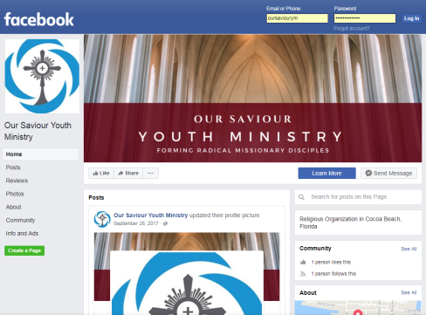
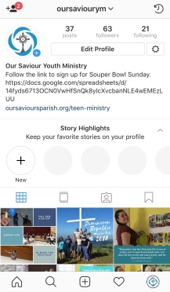

Instagram and Facebook
We have both an Instagram and Facebook page. Follow both to see pictures from all our activities and stay up to date on future events

Our Website
Check out our website at oursavioursparish.org/teen-ministry

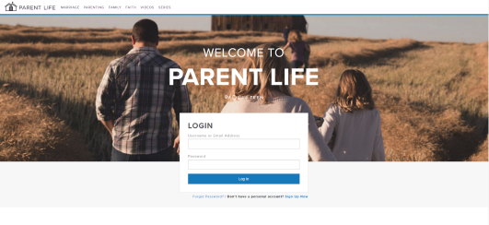
Parent Life
At the website ltparentlife.com, Life Teen posts great blogs and resources for you as a parent. Our parish code is saviour32931

Other Resources
For any questions you and your family may have about the Catholic Church and why we believe what we do, visit Catholic Answers at catholic.com.

Ascension Presents posts amazing YouTube videos about being Catholic.

Tightrope is a five minute podcast reflections for busy Catholics.
Service Hours
“Whatever you did for one of these least brothers of mine, you did for me.” (Mathew 25:40)

Parish & Community Service
Being a Christian, a Catholic, and a Disciple of Christ calls us to live our lives according to the example and instructions Jesus himself gave us. This is our mission as Church, and it’s a BIG responsibility! One of the most important lessons Jesus taught us was that we must be willing to be a servant to all people in His name. This means that we must actually DO something to be a disciple of Christ. By doing parish and community service, we demonstrate a willingness to show Christian responsibility to our mission. Service should be something that truly gives you an experience of discipleship.
Good examples of service include:

Altar Server
Music Ministry
Lector
Hospitality Minister
Parish Fall Festival Worker
Parish Respect Life Activities
Parish Family Promise
Soup Kitchens
St. Vincent de Paul
Volunteering for Children’s Activities
Volunteering for Parish Activities
Helping Elderly Neighbor

NOTE: Some things, although worthy endeavors, are NOT considered service for this activity:
Cleaning your house
Mowing your lawn
Babysitting your siblings
Working with animals
Anything you get paid to do

All Candidates for Confirmation should complete a minimum of 15 hours of service.

All Service Hours need to be completed by:
MARCH 4th, 2019

CONFIRMATION COMMUNITY SERVICE LOG

NAME OF CANDIDATE:

This section is to be filled in each time service is completed and verified by an adult other than the candidate’s parent
Date of Service | Start Time | End Time | Hours Served | COMMUNITY SERVICE PERFORMED | Signature of person authorizing service
 | xcxc
TOTAL HOURS: |  |  |  | (Hours must be listed by whole or half hour increments)

Sign below if the above information is correct and if the total number of service hours has been met.
Candidate Signature _____________________________________________________Date_____________
Parent (or Guardian) Signature _______________________________________________Date_____________

Describe how your gifts of time and talent were used to show Jesus to those you served:
__________________________________________________________________
__________________________________________________________________
__________________________________________________________________
__________________________________________________________________
__________________________________________________________________
__________________________________________________________________
__________________________________________________________________
__________________________________________________________________
__________________________________________________________________
__________________________________________________________________
__________________________________________________________________
__________________________________________________________________
__________________________________________________________________
__________________________________________________________________
__________________________________________________________________
__________________________________________________________________
__________________________________________________________________
__________________________________________________________________
__________________________________________________________________
__________________________________________________________________
__________________________________________________________________

