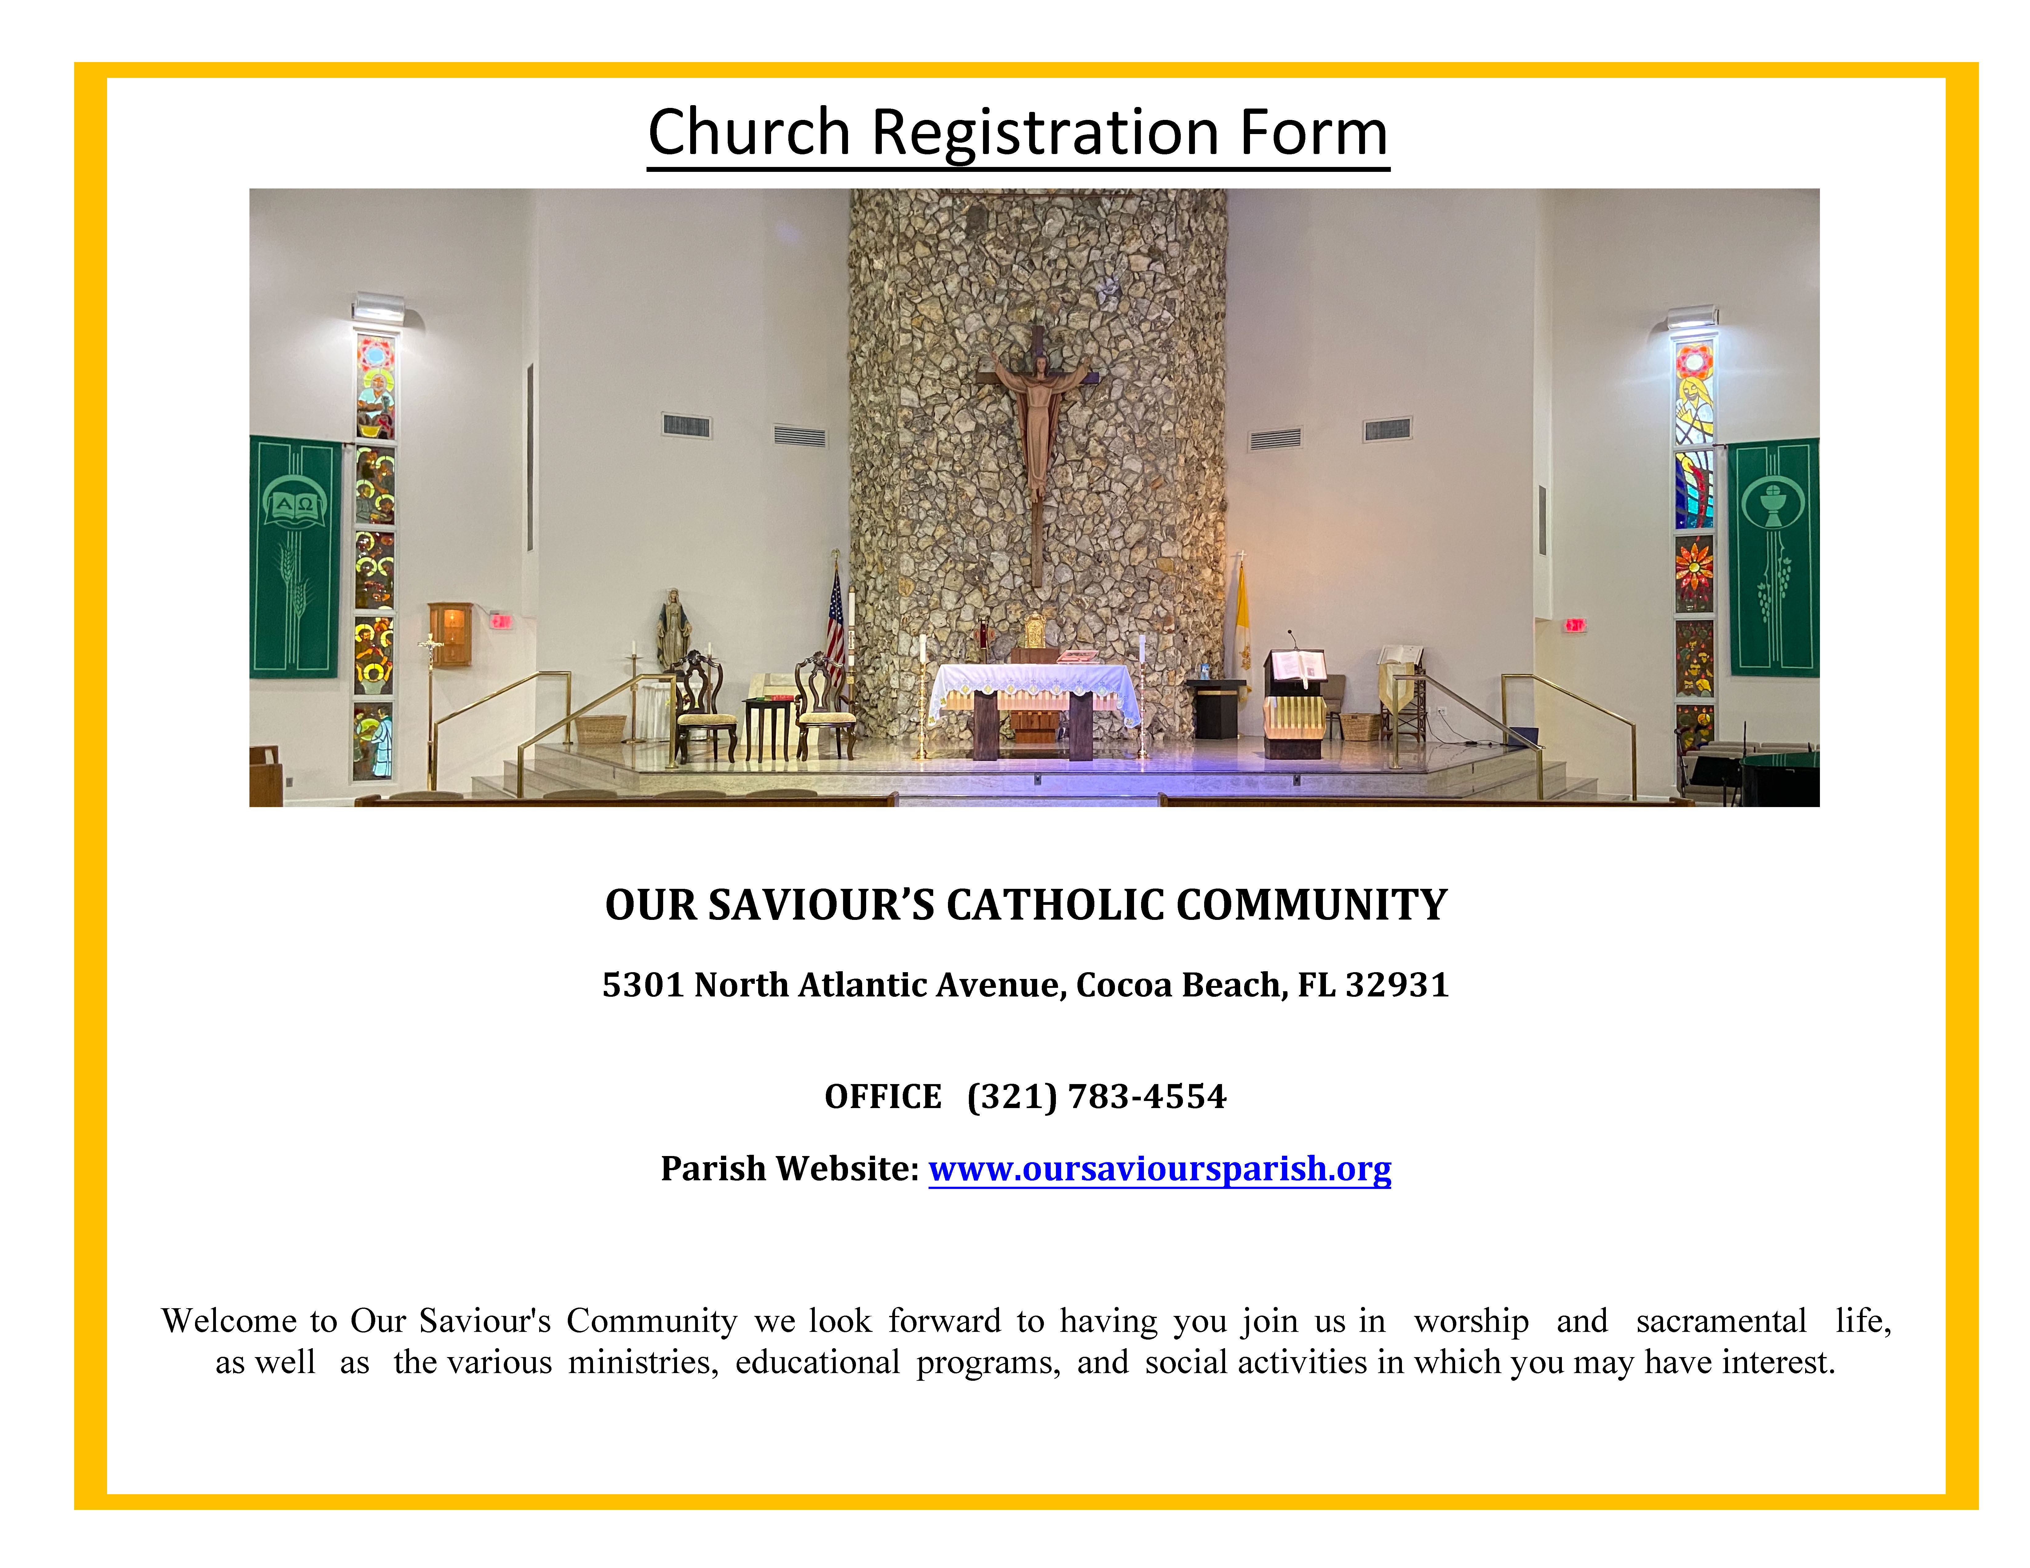

OUR SAVIOUR’S CATHOLIC COMMUNITY
(Please complete form and turn into the office.)
Registration Date_________________ Envelope#_____________
Male Head of Household Information Cell Phone: |  |  |  |  |  |  |  |  | Female Head of Household Information Cell Phone:
Last Name: First Name: |  |  |  |  |  |  |  |  | Last Name: First Name:
Title: (e.g. Mr., Mrs., Dr.) Nickname: |  |  |  |  |  |  |  |  | Title: (e.g. Mrs. Ms. Dr.) Maiden Name:
Birthdate: |  |  |  |  |  |  |  |  | Birthdate: Nickname:
Occupation: |  |  |  |  |  |  |  |  | Occupation:
Religion: |  |  |  |  |  |  |  |  | Religion:
Sacraments: : Baptism ◻ 1st Communion ◻ Confirmation ◻ |  |  |  |  |  |  |  |  | Sacraments: Baptism ◻ 1st Communion ◻ Confirmation ◻
Marital Status (check): Married ◻ Date of Marriage: Single ◻ Separated ◻ Divorced ◻ Annulled ◻ Widowed ◻
Married in Catholic Church ◻ Married Civilly ◻ Other ◻ ______________________
FAMILY INFORMATION
Street Address: Permanent: ◻ Seasonal: ◻ from:___________to_____________
City/State/Zip:
Home Phone:
Family Email Address(es):
Family Mailing Address (if different than street address above):
(Children over the age of 21 should have their own registration card.)
FAMILY MEMBER INFORMATION
Children at Home  First Name | Last Name  (If different) | Sex  M/F |  | Birthdate | Relationship  (son,daughter,niece,etc.) |  |  | Religion |  |  | Baptized | First Communion | Confirmation | Name of School Attending
1) |  |  |  |  |  |  |  |  |  |  | Y◻ N◻ | Y◻ N◻ | Y◻ N◻
2) |  |  |  |  |  |  |  |  |  |  | Y◻ N◻ | Y◻ N◻ | Y◻ N◻
3) |  |  |  |  |  |  |  |  |  |  | Y◻ N◻ | Y◻ N◻ | Y◻ N◻
4) |  |  |  |  |  |  |  |  |  |  | Y◻ N◻ | Y◻ N◻ | Y◻ N◻
5) |  |  |  |  |  |  |  |  |  |  | Y◻ N◻ | Y◻ N◻ | Y◻ N◻
Others at Home  (e.g.adult children, Grandparents, etc.) | First Name |  | Last Name |  |  | Sex M/F | Birthdate |  |  | Relationship |  | School/College/Occupation
 | Does anyone in your household have special needs? Yes ◻ No ◻
Emergency Contact and Phone Number:

