2018-2019 High School Registration
aell@oursavioursparish.org
CONFIRMATION PREPARATION FEES $90 per child, HIGH SCHOOL: Free

Click here to enter text. | Click here to enter text.
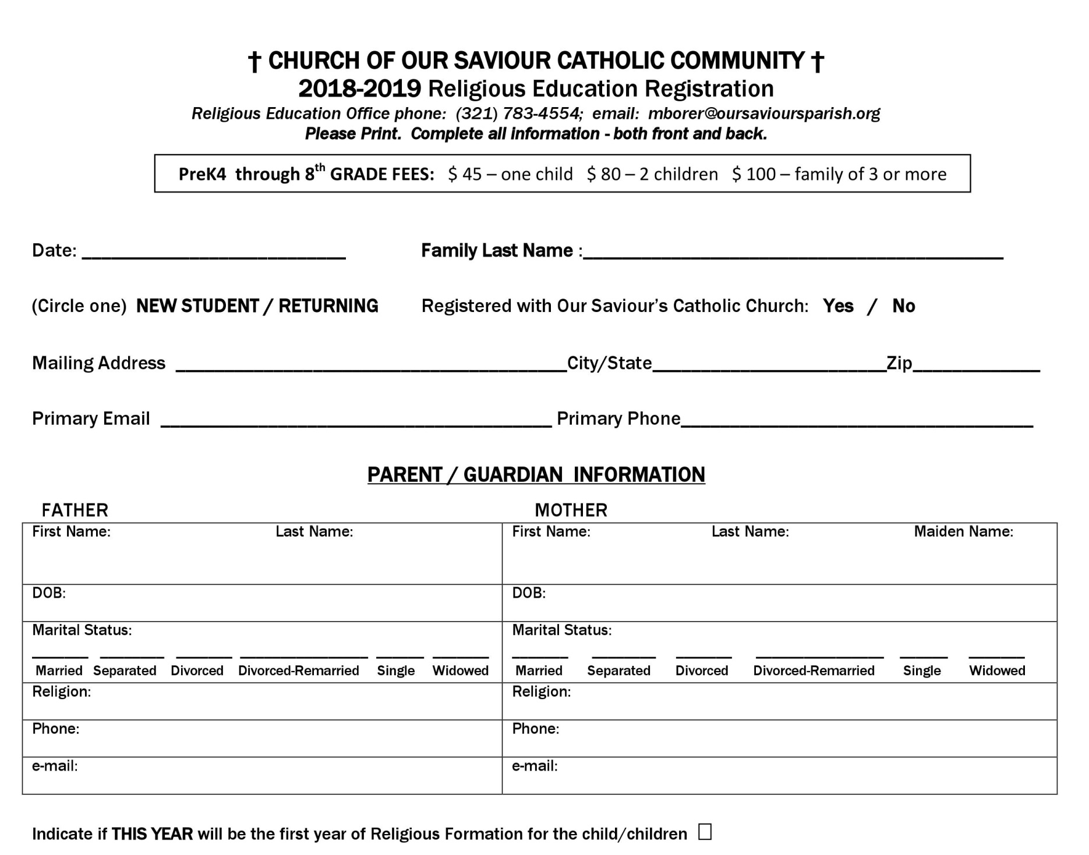

My child(ren) is a | Click to select New or Returning | Registered with Our Saviour’s Catholic Church: | Click to select

Click here to enter text. | Click here to enter text. | Click to enter.

Click here to enter text. | Click here to enter text.

Click here to enter text. |  |  |  | Click here to enter text. |  |  | Click here to enter text. |  |  |  | Click here to enter text. |  | Click here to enter text.
Click here to enter text MM/DD/YYYY. |  |  |  |  |  |  | Click here to enter text MM/DD/YYYY.
☐ | ☐ |  | ☐ | ☐ | ☐ | ☐ | ☐ |  | ☐ | ☐ |  | ☐ |  | ☐ | ☐
 |  | Click here to enter text. |  |  |  |  |  | Click here to enter text.
 |  | Click here to enter text. |  |  |  |  |  | Click here to enter text.
 |  | Click here to enter text. |  |  |  |  |  | Click here to enter text.

☐

Child's Name  * if different last name  please include |  | Lives with:  Mom / Dad  Grandparent Guardian |  | RE  Grade | School  Grade |  | Name of School  Attending |  | Birthdate |  | Gender | Parish of Baptism |  | Parish of  First Communion | Ministry  student currently serving in
Name |  | Lives with |  | RE Grade | School Grade |  | School |  | MM/DD/YYYY |  | M/F | Parish Name |  | Parish Name | Ministry Name
Name |  | Lives with |  | RE Grade | School Grade |  | School |  | MM/DD/YYYY |  | M/F | Parish Name |  | Parish Name | Ministry Name
Name |  | Lives with |  | RE Grade | School Grade |  | School |  | MM/DD/YYYY |  | M/F | Parish Name |  | Parish Name | Ministry Name
Name |  | Lives with |  | RE Grade | School Grade |  | School |  | MM/DD/YYYY |  | M/F | Parish Name |  | Parish Name | Ministry Name
Name |  | Lives with |  | RE Grade | School Grade |  | School |  | MM/DD/YYYY |  | M/F | Parish Name |  | Parish Name | Ministry Name
*If child was baptized outside of Our Saviour’s Parish, please provide a copy of the Baptismal certificate.
LOCAL EMERGENCY CONTACT: In the event parents or legal guardians cannot be reached
Emergency Contact Name |  |  | Click here to enter text. |  |  |  |  |  | Relationship to Student |  |  |  | Click here to enter text.
Home Phone | Click here to enter text. |  |  |  |  |  |  | Cell Phone |  | Click here to enter text.
Person(s) Authorized to pick up student |  |  |  |  |  | Click here to enter text.

Click to choose an item.
Click here to enter text.
Click to choose an item
Click here to enter text.
Click to choose an item
Click here to enter text.
Click to choose an item
Click here to enter text.
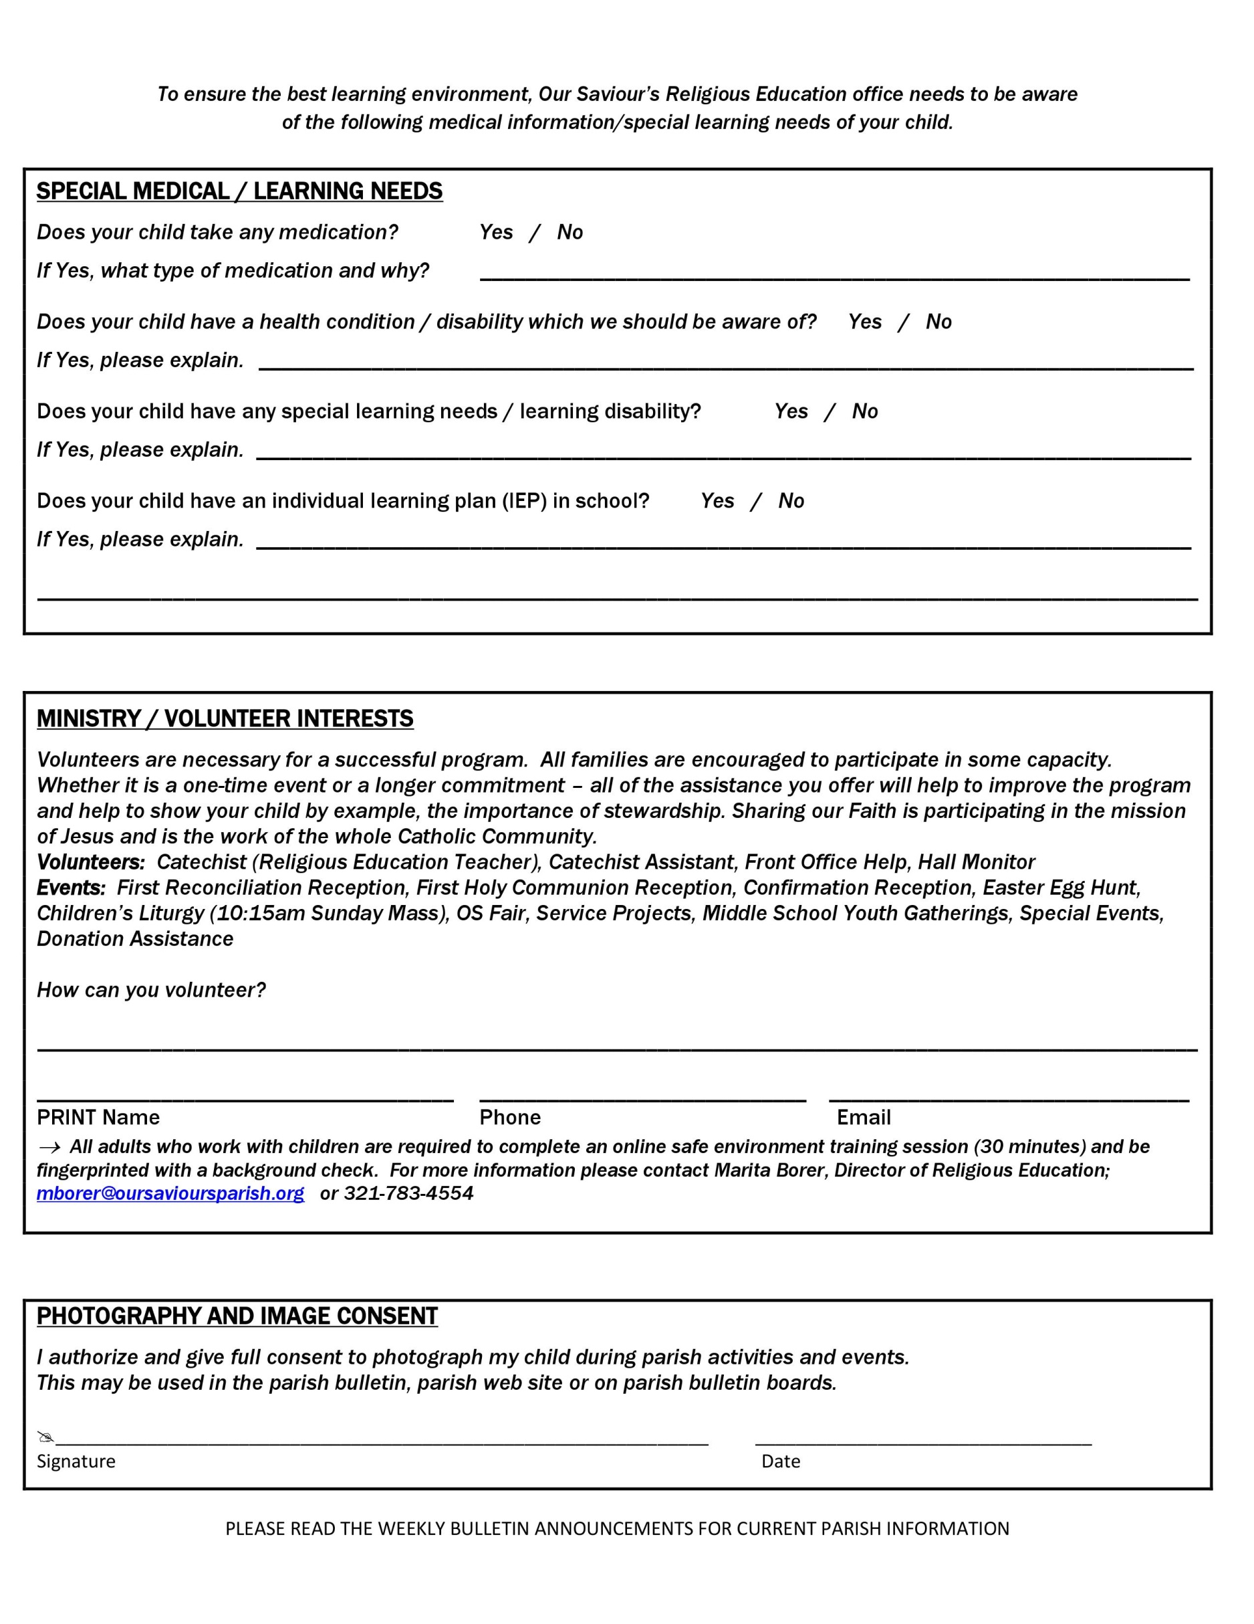

Click here to enter text.
Click here to enter text. | Click here to enter text. | Click here to enter text.

