|  |  |
| --- | --- |
| Click here to enter text. | Click here to enter text. |

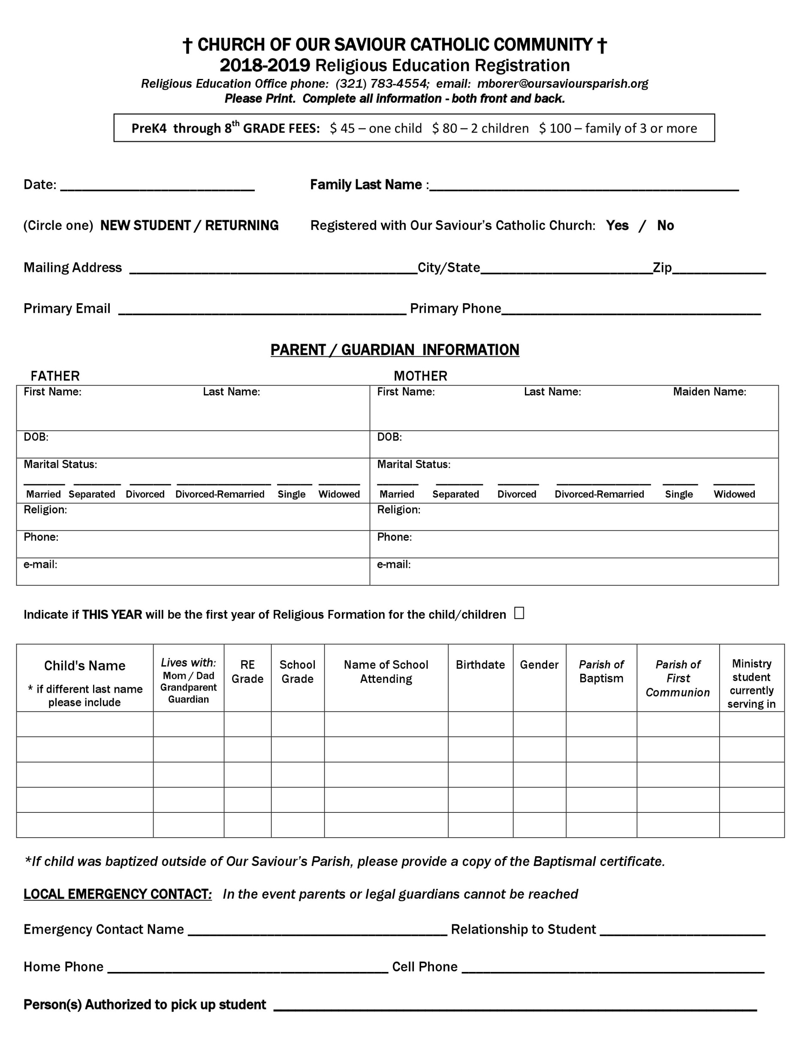

|  |  |  |  |
| --- | --- | --- | --- |
| My child(ren) is a | Click to select New or Returning | Registered with Our Saviour’s Catholic Church: | Click to select |

|  |  |  |
| --- | --- | --- |
| Click here to enter text. | Click here to enter text. | Click to enter. |

|  |  |
| --- | --- |
| Click here to enter text. | Click here to enter text. |

|  |  |  |  |  |  |  |  |  |  |  |  |  |  |  |  |
| --- | --- | --- | --- | --- | --- | --- | --- | --- | --- | --- | --- | --- | --- | --- | --- |
| Click here to enter text. | | | | Click here to enter text. | | | Click here to enter text. | | | | Click here to enter text. | | Click here to enter text. | | |
| Click here to enter text MM/DD/YYYY. | | | | | | | Click here to enter text MM/DD/YYYY. | | | | | | | | |
|  |  | |  |  |  |  |  | |  |  | |  | |  |  |
|  | | | | | | | | | | | | | | | |
|  | | Click here to enter text. | | | | |  | Click here to enter text. | | | | | | | |
|  | | Click here to enter text. | | | | |  | Click here to enter text. | | | | | | | |
|  | | Click here to enter text. | | | | |  | Click here to enter text. | | | | | | | |

|  |
| --- |
|  |

|  |  |  |  |  |  |  |  |  |  |  |  |  |  |  |  |
| --- | --- | --- | --- | --- | --- | --- | --- | --- | --- | --- | --- | --- | --- | --- | --- |
| Child's Name  * if different last name  please include | | *Lives with:*  Mom / Dad  Grandparent Guardian | | RE  Grade | School  Grade | | Name of School  Attending | | Birthdate | | Gender | *Parish of* Baptism | | *Parish of*  *First Communion* | Ministry  student currently serving in |
| Name | | Lives with | | RE Grade | School Grade | | School | | MM/DD/YYYY | | M/F | Parish Name | | Parish Name | Ministry Name |
| Name | | Lives with | | RE Grade | School Grade | | School | | MM/DD/YYYY | | M/F | Parish Name | | Parish Name | Ministry Name |
| Name | | Lives with | | RE Grade | School Grade | | School | | MM/DD/YYYY | | M/F | Parish Name | | Parish Name | Ministry Name |
| Name | | Lives with | | RE Grade | School Grade | | School | | MM/DD/YYYY | | M/F | Parish Name | | Parish Name | Ministry Name |
| Name | | Lives with | | RE Grade | School Grade | | School | | MM/DD/YYYY | | M/F | Parish Name | | Parish Name | Ministry Name |
|  | | | | | | | | | | | | | | | |
| *\*If child was baptized outside of Our Saviour’s Parish, please provide a copy of the Baptismal certificate.* | | | | | | | | | | | | | | | |
| **LOCAL EMERGENCY CONTACT*:***  *In the event parents or legal guardians cannot be reached* | | | | | | | | | | | | | | | |
| Emergency Contact Name | | | Click here to enter text. | | | | | | Relationship to Student | | | | Click here to enter text. | | |
| Home Phone | Click here to enter text. | | | | | | | Cell Phone | | Click here to enter text. | | | | | |
| **Person(s) Authorized to pick up student** | | | | | | Click here to enter text. | | | | | | | | | |

|  |  |  |  |
| --- | --- | --- | --- |
| Click to choose an item. | | | |
| Click here to enter text. | | | |
|  | | | Click to choose an item |
| Click here to enter text. | | | | |
|  | | | Click to choose an item | |
| Click here to enter text. | | | | |
|  | | Click to choose an item | | |
| Click here to enter text. | | | | |

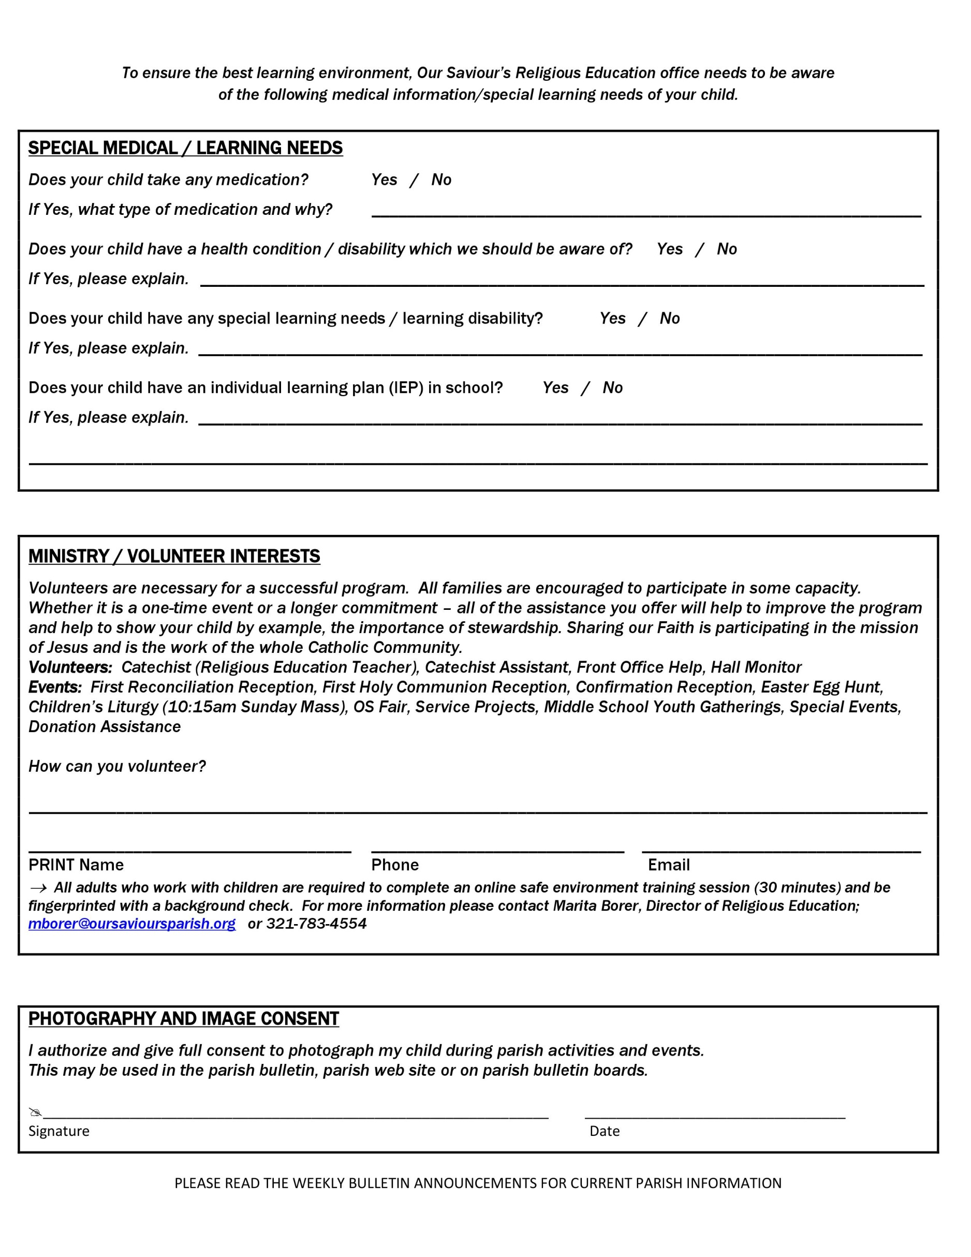

|  |  |  |
| --- | --- | --- |
| Click here to enter text. | | |
| Click here to enter text. | Click here to enter text. | Click here to enter text. |